Jet Ski Rentals & Tours

Welcome To Clearwater Jetski Tours and Rentals
We are located at 25 Causeway Boulevard, Slip 22, Clearwater, Florida 33767
We are directly behind the Crabby Bill's Restaurant in the Clearwater Marina which is next to the round about as you are entering Clearwater Beach.
Come on in and visit our website. We offer jet ski rentals and jet ski tours. Our clearwater jet ski rentals or waverunner rentals rent by the hour. Our clearwater jet ski rentals are available for multiple hours. You may rent up to 3 hours with clearwater beach jet ski rentals. Our clearwater jet ski tours lasts approximately 1 1/2 hours. Our jet ski tours can last up to 3 hours. You may choose the tour that best suites you.
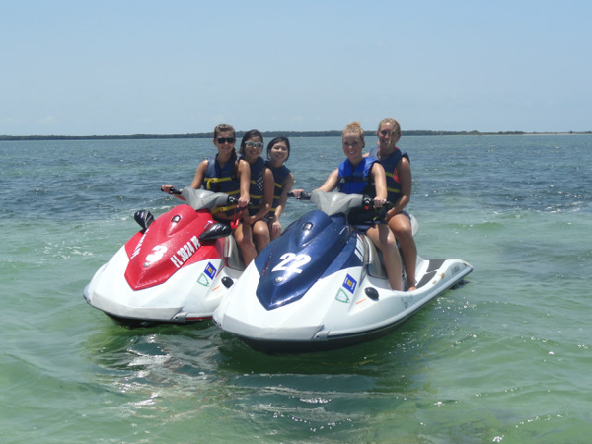

Dolphin Exploration Tour
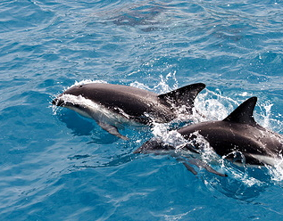
The Dolphin Exploration Tour last approximately two hours and will take you from Clearwater Bay out Clearwater Pass on the beautiful emerald green waters of the Gulf of Mexico in search of the Sun Coast’s favorite…the Bottlenose Dolphin. In addition to offering guaranteed dolphin sightings, your Captain will highlight some fascinating facts about the natural wonders our Gulf Coast offers as well as point out celebrity mansions along the way. The tour offers something for everyone, from Tommy the Turtle Explorer Time for the kids to unlimited beer, wine, our signature vodka punch and soft drinks for the adults!** Just sit back, relax and enjoy the music from our state of the art sound system. .
Adult Basic Entry | $22.00*
(Does not include The Tropics Wristband)
The Tropics Wristband | $10.00*
(Includes unlimited beer, wine, signature vodka punch & soft drinks)
Children (ages 4-12) | $15.00*
Children (ages 3 & Under) | FREE
** The Tropics Wristband provides access to unlimited beer, wine, our signature vodka punch and soft drinks.
Subject to passenger minimums.
*Plus Tax

Sunset Celebration Cruise
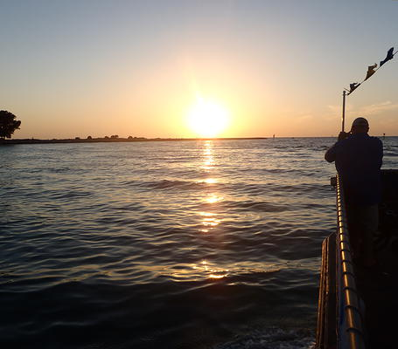
The Tropics Sunset Celebration Cruise is a 2-hour tour from Clearwater Bay through Clearwater Pass. Sail the beautiful waters of the Gulf of Mexico as you view a beautiful Florida sunset and if you’re lucky you may witness the legendary green flash. Your Captain will point out some interesting facts about the natural wonders of the Gulf Coast as well as sights along the way. We are pleased to offer our guests The Tropics Wristband for unlimited beer, wine, our signature vodka punch, soft drinks and a special champagne toast at sunset. Top
Adult Basic Entry | $22.00*
(Does not include all The Tropics Wristband)
The Tropics Wristband | $10.00*
(Includes unlimited beer, wine, signature vodka punch & soft drinks)
Children (ages 4-12) | $15.00*
Children (ages 3 & Under) | FREE
** The Tropics Wristband provides access to unlimited beer, wine, our signature vodka punch and soft drinks.
Subject to passenger minimums.
*Plus Tax

Saturday Night Party Cruise
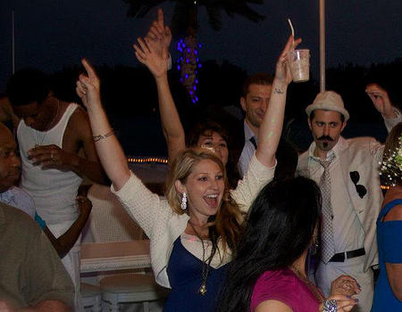
The Saturday Night Party Booze Cruise is a 2-hour Sunset Cruise for our guests 21 and over. This Party Booze Cruise includes our Tropics Wristband for unlimited beer, wine, our signature vodka punch and soft drinks. We also offer a full service cocktail bar where you can order your favorite cocktail or frozen drink. We set sail on the beautiful waters from Clearwater Bay through Clearwater Pass to view the best that Florida has to offer, an amazing sunset on the Gulf of Mexico. And if you’re lucky, you may witness the legendary green flash. Party to your favorite tunes from our state of the art sound system. If you’re looking for a rockin’ good time, this is the cruise for you. DJ Boogie Nites performs live some Saturday Nights.
Group rates available.
Adult Premium Ticket | $35.00*
(Adults 21 & over onlly)
The Tropics Wristband: included (Includes unlimited beer, wine, our signature vodka punch and soft drinks) ** The Tropics Wristband provides access to unlimited beer, wine, our signature vodka punch and soft drinks.
Subject to passenger minimums.
*Plus Tax

Kayak & paddleboard Tour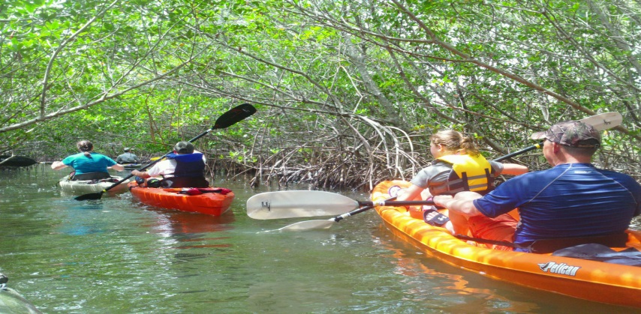
Prices – Paddle boarding and Kayaking
SUP rentals……….$70 per board/day
Kayak rentals……….$65 per kayak/day
SUP Eco-Tours…………$70 per person (2+ hours)
Kayak Eco-Tours……….$65 per person (2+ hours)
*** SUP and Kayak mixed Eco-Tours available***
1⁄2 Day Eco-Adventure tours $125 per person (4 hours) (ask about group rates)
Named the #1 natural beach in the nation in 2008, this Florida State Park is one of only a few remaining natural islands in Florida. The island is accessible only by watercraft via a 108-slip marina with sandy beach and floating dock access for canoes and kayaks. A hurricane closed this pass a few years ago and the island is now connected with Clearwater Beach to the south. There is also a three-mile upland nature trail and a number of surrounding spoil islands. The waters along the eastern side of the island are lush with seagrass beds, encouraging the presence of marine mammals and numerous species of fish. The island itself is home to a number of nesting birds, including pelicans, snowy egrets and blue herons.

Parasailing
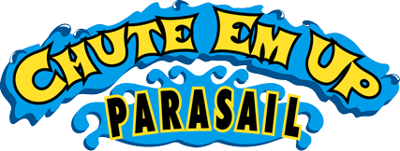

Imagine flying up to 800 feet above the Gulf of Mexico, then the boat stops! You slowly drift downward and just when you are about to get dunked, WHOOOSH, the boat takes off and you go soaring back up!
RIDE THE WIND under our parasail and you'll never again be happy just being a landlubber. Grin to the thrill and the beauty of soaring hundreds of feet above the Gulf of Mexico. The colorful parasail sparkles overhead while you enjoy a bird’s eye view in a peaceful and serene world. The ride is breathtaking and thoroughly enjoyable. The parasail is very stable so you will enjoy the ride without having to steer. And landings are always safe and gentle.
Take off & land on the deck of our specially designed winchboat for a safe ride!

Located in the Clearwater Municipal Marina, Slip 8

Private Yacht Charters
Thank you for considering Yacht Sensation for your group!

This is something they might want to consider ... we can even pick them up at the docks across the street from your property. We recently did this menu for Tech Data and dropped them off at Island Way for their dinner.

Please feel free to have them contact me directly if they have any questions or would like something a little different (such as a more typical lunch or dinner cruise). Keep in mind the pricing below was figured on the minimum of 70 guests.

Exclusive use of Yacht Sensation - Charter Fee: $1050.00
Based upon 2 hours of cruising with a minimum of 70 guests

Fruit & Cheese Station (Fresh Fruit, Imported and Domestic Cheeses served with Assorted Crackers)

Hand Passed Hors d'Oeuvres:
Thai Tuna Tartar on Crispy Wonton
Brie & Raspberry In Puff Pastry
Creole Shrimp Bruschetta
Lobster Empanada
Andouille Stuffed Mushroom Caps
Disc Jockey
Cash Bar

With service charge and tax, $2920.40

Bay Area Shopping Centers
There are more than a dozen shopping malls in the greater Tampa Bay area frequented by area residents and visitors alike, each with its own distinctive style and personality. Five malls in particular offer shoppers exceptional variety, convenience and an overall pleasant shopping experience.
1. Westfield Citrus Park
Westfield Citrus Park, at 8021 Citrus Park Town Center, Tampa, features anchor stores Dillard's, JCPenny, Macy's and Sears. There are several clothing stores, such as Abercrombie & Fitch, as well as stores specializing in home furnishings and design, jewelry, shoes, toys, sporting goods and more. In addition to
2. Largo Mall
Largo Mall, at 10500 Ulmerton Road, Largo, boasts anchor stores Target, PetSmart, Staples and Michaels in an open-air setting. Clothing stores include Bealls and Marshalls. For the hungry shopper, Largo Mall boasts an outstanding selection of eateries, including Chili's, Red Lobster, Olive Garden and Sweet Tomatoes.
3. Westfield Countryside Mall
Westfield Countryside Mall, at 27001 U.S. Highway 19 N., Clearwater, is home to several department stores such as Sears, Dillard's, JCPenny and Macy's. Also found in the mall are Bond Jewelers, Country Cabin, FYE, Gap, Gordon Jewelers, Spencer Gifts, Things Remembered, Yankee Candle and many others. In addition to the food court, shoppers can enjoy a snack or a meal at Ruby Tuesday Restaurant, Schnickel Fritz or TooJay's Gourmet Deli.
4. Tampa International Plaza & Bay Street
International Plaza, adjacent to Tampa International Airport, is the most distinctive shopping and dining destination of Florida's West Coast. Three fashionable department stores, over 200 specialty shops and Bay Street at the Plaza... an open-air village of fine restaurants and small boutiques.

5. WestShore Plaza
WestShore Plaza, at 250 WestShore Plaza, Tampa, is an enclosed mall just off I-275 in Tampa. The mall's anchor stores include Sears, JCPennys, Macy's and Saks Fifth Avenue. WestShore Plaza is home to several high-end retail chains including Ann Taylor and Lindt & Sprüngli. Aside from the many eateries located in the mall's food court, WestShore boasts upscale restaurants including Mitchell's Fish Market and Palm Restaur

Local Golf Affiliates
Bardmoor Golf & Tennis Club is a public course located at 8001 Cumberland Road, Largo, Florida. Bardmoor is the former home of the PGA/LPGA JC Penny Classic, offering the player; broad, generous fairways that invite you to hit away, glistening water features and of course, abundant sunshine. Renovated in 2003 by Champions Tour Player and NBC Golf Analyst, Gary Koch.
6:45AM ~ 12:59PM $85
1:00PM ~ 3:59PM $65
After 4:00PM $40
Bayou Club is a private course located at 7979 Bayou Club Blvd., Largo, Florida.
Designed by famed Course Architect Tom Fazio, the layout of these 18 championship caliber holes stand as a luxurious centerpiece of an exclusive community. Bayou Club’s golf course gently weaves its way through oaks and pines, marshes and bayous. Another hallmark of Bayou’s success is the playing condition of it’s golf course. Meticulous maintenance practices and continual site improvements keep the course in outstanding shape every month of the year.
One Day Membership:
$95

Fishing Charters
Fishing tours can be arranged for in or offshore depending on the fishing experience you wish to have. Both will offer a great experience and vary from $500.00 to $650.00 for a half day private charter. We work with many captains and if you wish for more information on some of our favorites, feel free to ask. Examples will be Captain Tysons Wallerstein of Flats Monster fishing charters (in shore) www.flatsmonster.com . Captain Tyson is an amazing captain that specializing in a wide variety of species including Redfish, Snook, Trout, Grouper, Kingfish, and the might Tarpon amongst the numerous other species our pristine waters of the Florida Gulf Coast have to offer. Capt. Tyson has what it takes to make a day out on the water an exciting experience for the whole family!
Captain Jack Vasilaros with Hooked For Life Charters (off shore) www.hookedforlifecharters.com. Jack is the youngest captain to compete competitively and win multiple local King Mackerel and Tarpon Tournaments. At only 24 years of age he has won the biggest and most prestigious King Mackerel event on the west coast of Florida. Captain Jack specializes in Tarpon, Shark, King Mackerel, Barracuda, Amberjack, Grouper, Snapper, Trout, Snook and Redfish.
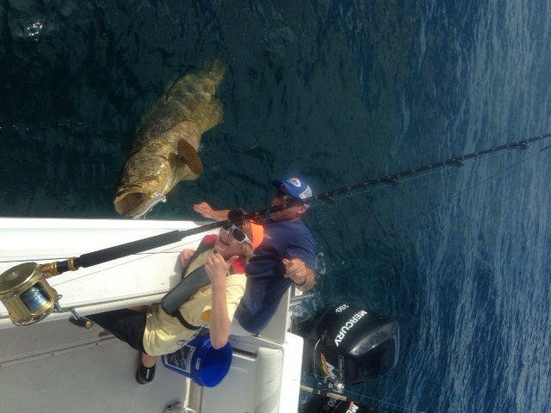

http://www.clearwater-fl.com/gov/depts/marine_aviation/ma_facilities/Marina/pdf/Marina_Tenant_Websites.pdf
(good website for commercial charters)

Dolphin Adventure Tour

Join us aboard our Catamaran “Nicholas’ Journey” to be a part of our Wild Dolphin Research Program and help us study our local dolphin population! Our Program is entirely funded by guests who join our field biologists each day on the Dolphin Adventure Tours.
Last August, Clearwater Marine Aquarium initiated a photo identification study to document the lives of the bottlenose dolphin population of Clearwater Bay and Clearwater Harbor. To date, our field biologists have identified and cataloged more than 80 dolphins using pictures taken of their dorsal fins.
As we tour Clearwater Bay’s estuary system you will:
- Learn about members of our local dolphin population
- Learn what it takes to be Dolphin SMART
- Be a part of our mission and help us protect and preserve our marine environment as we study its inhabitants
- Play Bird Bingo and identify birds of prey and wading birds including, osprey, ibis, egrets, great blue herons, pelicans and more
- Conduct onboard water quality tests and plankton tows
- Kids can participate in our Jr. Marine Biologist Program while on board
Receive a complimentary photo of your expedition!
Time: Weekdays 11:30am
Weekends 11:00am and 1:30pm
Prices:
Adults $32.95
Seniors (60+) $28.95
Children (3-12) $21.95
Space: Limited to 40 participants per trip.

Bay Area Museums

Tampa Bay History Center
The Tampa Bay History Center - a Smithsonian Institution Affiliate - includes three floors of cutting-edge exhibits exploring 12,000 years of Florida's history and culture. Discover the stories of Se...
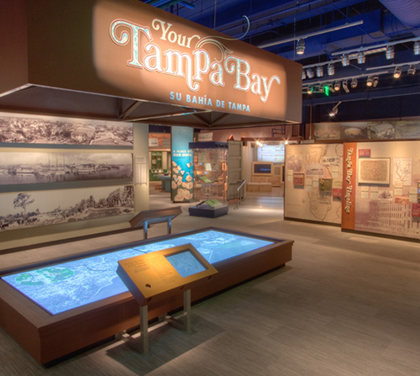

American Victory Ship Mariners Museum
The American Victory Ship is one of only four operational World War ll ships in the U.S. As a national historic landmark, the mariners museum ship is a prize attraction offering educational tours, ev...
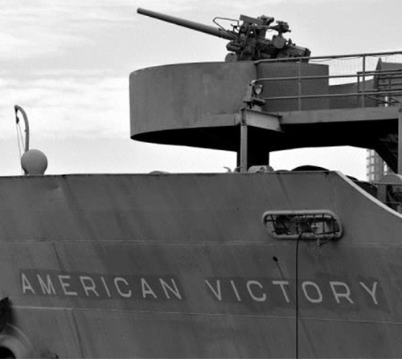

Armed Forces History Museum
The Armed Forces History Museum, housed in a 35,000 sq ft renovated building, is dedicated to honorably preserving our military history and educating our current and future generations as to the sacr...
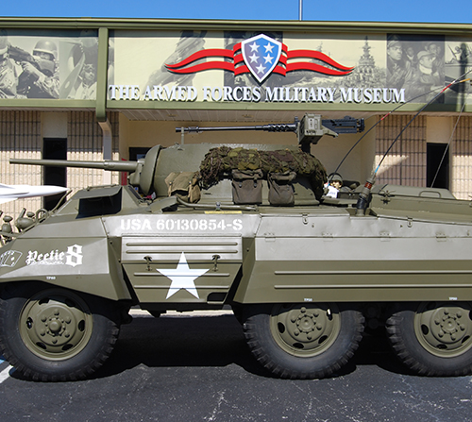

Cracker Country Living History Museum
Discover Cracker Country, a rural Florida outdoor living history museum, and experience how the daily lives of early Florida settlers revolved around chores, seasons, family, and community. Now, liv...
  - Map It
  - Favorite
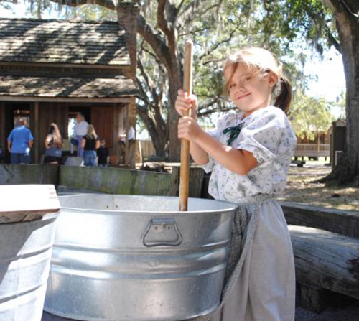

Florida Museum of Photographic Arts, Inc.
The Florida Museum of Photographic Arts is dedicated to exhibiting important photographic art as central to contemporary life and culture. FMoPA collects, preserves, and exhibits historic and contemp...
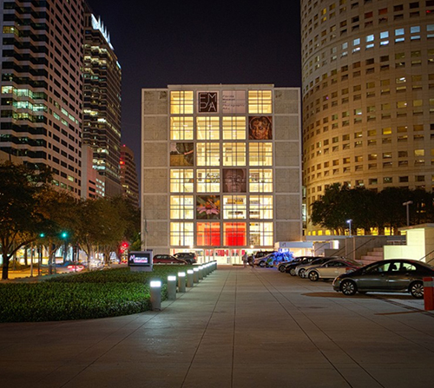

Glazer Children's Museum
Designed to inspire children and families by creating learning opportunities around innovative play and discovery, the 53,000 square foot Glazer Children's Museum will have a combination of permanent...
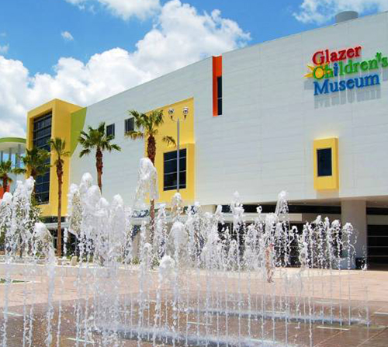

Henry B. Plant Museum
With it's magnificent Moorish architecture, opulent furnishings, and tropical gardens, a visit to the restored rooms of the former Tampa Bay Hotel, will transport you to Victorian splendor. Docent an...
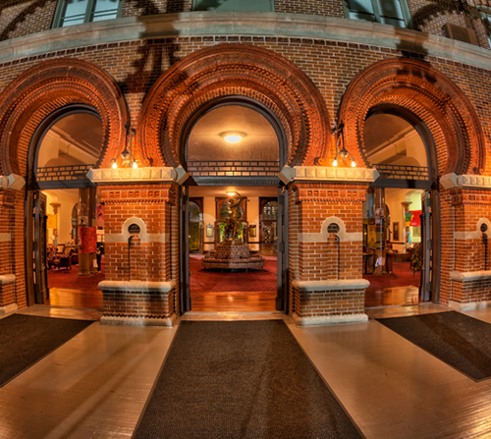

J.C. Newman Cigar Company
J.C. Newman is America's oldest family owned cigar company and the last operating cigar factory in Cigar City with brands including Diamond Crown, MAXIMUS, Cuesta Rey, Brick House and El Baton.
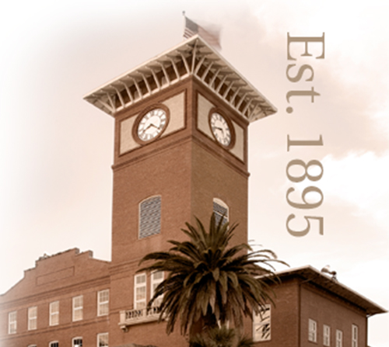

Morean Arts Center
The Morean Arts Center operates the best and most inspirational art venues in Downtown St. Petersburg. For an adventure into art, visit the Chihuly Collection, Morean Glass Studio & Hot Shop, Morean ...
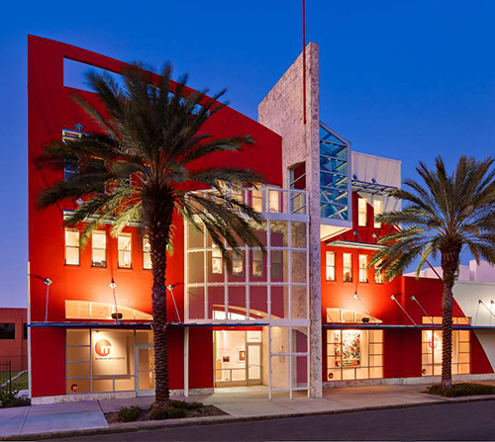

MOSI - Museum of Science & Industry
For children and adults. Experience what it's like to pedal a bicycle on a 1-inch cable suspended 30 feet above the ground or lie on a bed-of-nails in the Kids In Charge exhibit! Add to your MOSI exp...
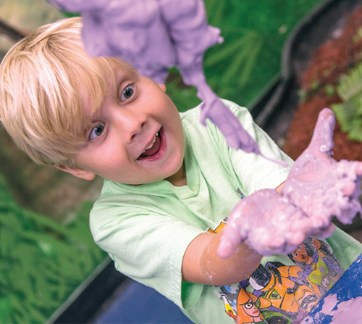

Tampa Baseball Museum at the Al Lopez House
The Tampa Baseball Museum at the Al Lopez House celebrates local baseball culture &#8211; from Little League to Major League, and everything in between, including: Factory, Inter-Social, Municipal, C...
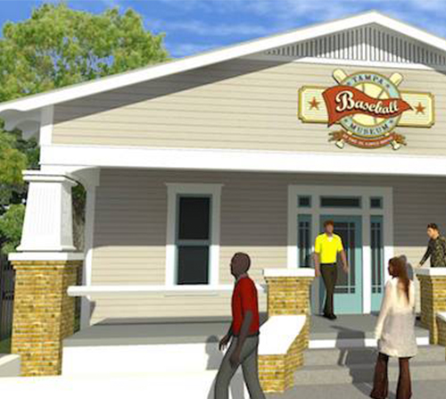

Tampa Firefighters Museum
Museum visitors can enjoy “hands-on” exhibits, education programs, rental space for events, a gift shop, donation or sponsorship opportunities, and additional benefits with annual membership. We are ...
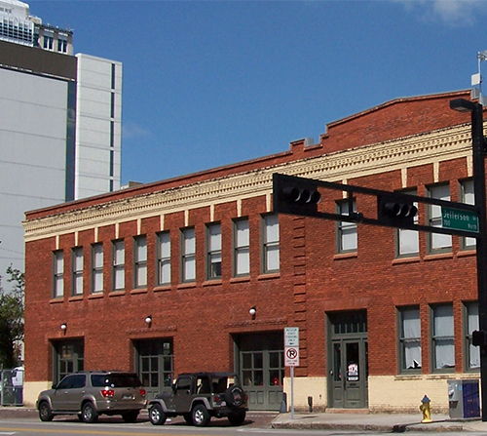

Tampa Museum of Art
The Tampa Museum of Art provides the region with world-class traveling exhibitions, a growing collection of contemporary and classical art, expanded educational programs and access to scenic outdoor ...
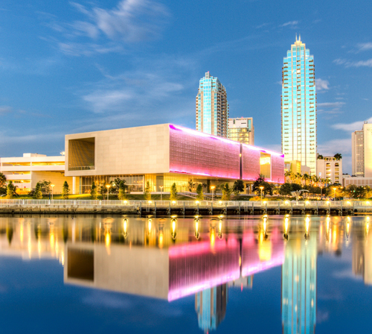

Tampa Police Museum
The Tampa Police Museum honors officers killed in the line of duty, preserves historically important records, books and police equipment, and urges the teaching of police science and work by offering...
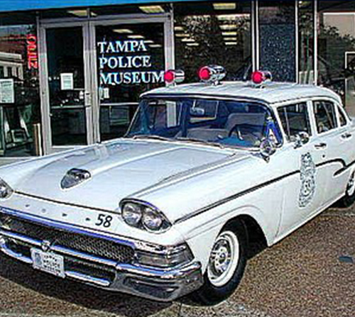

The Dali Museum
Soak in the brilliance as you are surrounded by an unparalleled collection of works by renowned artist Salvador Dalí. Enjoy an afternoon wandering through the awe-inspiring building and interactive g...
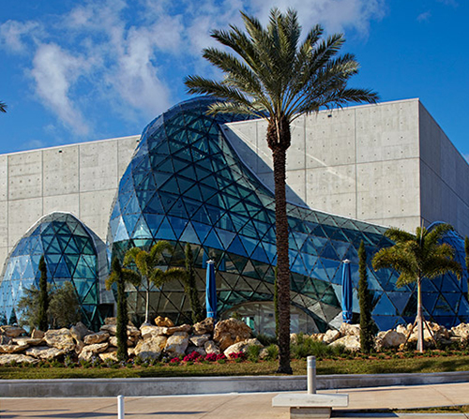

The Ringling
Located on the beautiful Sarasota Bay, visit the Art galleries, Ca d'Zan Mansion, Circus Museum including The Wisconsin Rail Car and the Howard Bros. Circus miniature, Historic Asolo Theater, and lus...
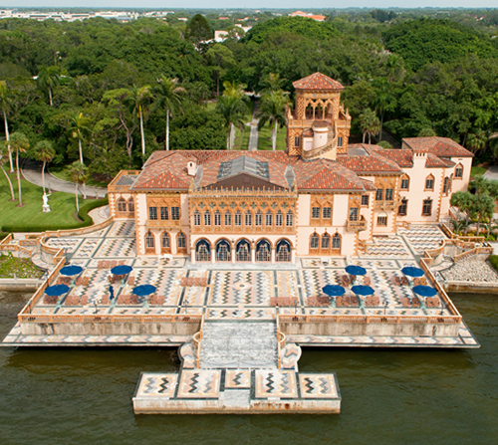

University of South Florida Contemporary Art Museum
USF CAM brings vital, investigative and scholarly exhibitions of contemporary art to the University and the Tampa Bay community. To complement our exhibitions program, USF CAM additionally organizes ...
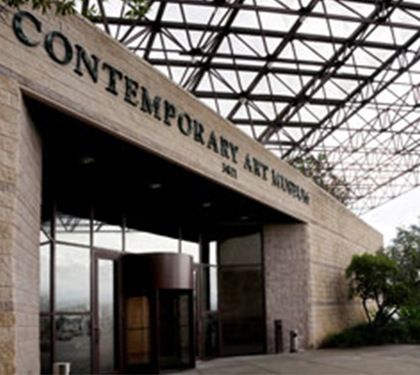

Ybor City Museum State Park
An urban park and museum in the heart of Tampa's National Historic Landmark District focusing on the unique culture and history of Ybor City, Tampa's National Historic Landmark District and the birthplace of modern Tampa. The park consists of a main exhibit space housed in a 1923-era bakery building, a lush Mediterranean-style garden...
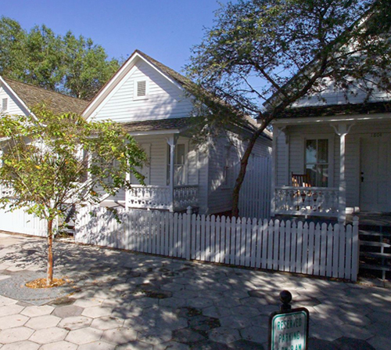

Area Restaurants by Cuisine

Americana
Tate Island Grill ~ Here at Sandpearl Resort ~ Pool Side, Serving Lunch & Dinner~ No Reservations Taken
Clear Sky Beachside Café ~ Serving Breakfast, Lunch & Dinner ~ Reservations Accepted
    - www.clearskycafe.com
Cork N Brew Bistro ~ Tapas & Craft Beers ~ Serving Dinner
727-483-5990
Hooters of Clearwater Beach ~ Serving Lunch & Dinner ~ No Reservations Taken
727-443-7263 www.hooters.com
Casual Seafood
Frenchy’s Rockaway ~ Very Casual Beachfront Dining ~ Serving Lunch & Dinner ~ No Reservations Taken
727-446-4844 www.frenchysonline.com
Frenchy’s Café (Original) ~ Small & Quaint ~ Serving Lunch & Dinner ~ No Reservations Taken
727-446-3607 www.frenchysonline.com
Palm Pavilion Beachside Grill & Bar ~ Very Casual Beachfront Dining ~ Serving Lunch & Dinner ~ No Reservations Taken
727-446-2642 www.palmpavilion.com
Cooters Restaurant & Bar ~ Casual Dining ~ Serving Lunch & Dinner ~ No Reservations Taken
727-462-2668 www.cooters.com
Crabby Bills Clearwater ~ Casual Dining ~ Serving Lunch & Dinner ~ No Reservations Taken
727-210-1313 www.crabbybills.com
Bait House Tackle & Tavern~ Casual Dockside Dining ~ Serving Lunch & Dinner ~ No Reservations Taken
727-446-8134 www.clearwaterbaithouse.com
Up Scaled Steak & Seafood
Caretta on the Gulf ~ Here at Sandpearl Resort ~ Lobby Level, Serving Breakfast, Lunch & Dinner, Reservations Reco
Bob Heilman’s Beach Comber ~ Fine Dining ~ Serving Lunch & Dinner ~ Reservations Recommended
727-442-4144 www.bobheilmans.com
Bobby’s Bistro & Wine Bar ~ Casual Upscale Dining ~ Serving Dinner ~ Reservations Recommended
    - www.bobbysbistro.com
Island Way Grill ~ Casual Upscale ~ Seafood with a Pan Asian Flair ~ 1 ½ Miles ~ Reservations Recommended
727-461-6617 www.islandwaygrill.com
Salt Rock Grill ~ Casual Upscale ~ Steak & Seafood ~ 10 Miles ~ Reservations Recommended
727-593-7625 www.saltrockgrill.com
Watercolour Steakhouse & Grill ~ Casual Upscale ~ 2 ¼ Miles at Marriott Sand Key ~ Reservations Recommended
727-596-1100 ww.watercolourgrill.com
Italian
Al & Stella’s ~ Italian ~ Serving Lunch & Dinner ~ Reservations Recommended
727-461-7000

Forlini’s ~ Italian ~ Serving Dinner ~ Reservations Recommended
    - www.forlinis.com

Cesare at the Beach ~ Fine Italian ~ Serving Dinner ~ 1 ¾ Miles ~ Reservations Recommended
727-449-8797 www.cesareatthebeach.com
Cristino’s Coal Oven Pizza ~ Serving Lunch & Dinner ~ 3 Miles ~ No Reservations Taken
727-443-4900 www.cristinospizzeria.com
Spanish/Cuban
The Columbia ~ Spanish/Cuban ~ Serving Lunch & Dinner ~ 2 ¼ Miles ~ Reservations Recommended
727-596-8400 www.columbiarestaurant.com
Mexican
Los Mayas ~ Serving Lunch & Dinner ~ 3 ½ Miles ~ No Reservations Taken
727-442-5545 www.losmayasclearwater.com
Casa Tina ~ Serving Lunch & Dinner ~6 ½ Miles ~ Reservations Recommended
727-734-9226 www.casatinas.com
Thai
Thai Coconut ~ Serving Dinner ~ 4 Miles ~ No Reservations Taken
727-441-1650 www.thethaicoconut.con
Chinese
Tan’s ~ Serving Dinner ~ No Reservations Taken
727-447-3663 www.tanschineserestaurant.com
Ivory Mandarin Bistro ~ Serving Dinner ~ 10 Miles ~ No Reservations Taken
727-734-3998 www.ivorybistro.com
Japanese
Kiku Japanese Restaurant ~ Serving Dinner ~ Reservations Recommended
727-461-2633 www.clearwaterbeachkiku.com
Kobe Japanese Steakhouse & Sushi Bar ~ Serving Dinner ~ Reservations Recommended866-543-5623 www.kobesteakhouse.com
French
Le Bouchon Bistro ~ Serving Dinner ~ 5 1/2 Miles ~Reservations Recommended
727-585-9777 www.Lebouchbistro
Café Ponte ~ Serving Dinner ~ 13 ½ Miles ~ Reservations Recommended
727-538-5768 www.cafeponte.com
Café de Paris Bakery ~ Serving Breakfast, Lunch & Late Afternoon ~ 6 Miles ~ No Reservations Taken
727-593-0277 www.cafedeparisbakery.com
La Cachette ~ Serving Dinner ~ 3 Miles ~ Reservations Recommended
727-5
Greek
Greek Town Grille ~ Serving Dinner ~ 4 Miles ~ Reservations Recommended
727-447-7800 www.greektowngrille.com
Mediterranean
Carmel Café & Wine Bar ~ Serving Lunch & Dinner ~ 12 Miles ~ Reservations Recommended
727-724-4228 www.carmelcafe.com
Mirage Restaurant ~ Serving Lunch & Dinner ~ 7 Miles ~ Reservations Recommended
727-724-3604 www.miragerestaurant.com
Indian
Clay Oven Indian Cuisine ~ Serving Lunch & Dinner ~ 15 Miles ~ Reservations Recommended
727-397-2869 www.clayovenoftampabay.com
India Grill Inc. ~ Serving Lunch & Dinner ~ 23 Miles ~ Reservations Recommended
727-894-1100 www.indiagrillinc.com
German
German Restaurant ~ Serving Lunch & Dinner ~ 23 Miles ~ Reservations Recommended
727-937-7400 www.the-german-restaurant.com
Vegetarian / Vegan
Natures Food Patch Market & Café ~ Serving Lunch & Dinner ~ No Reservations Taken
727-443-6703 www.naturesfoodpatch.com
Rawk Star Café ~ Serving Lunch & Dinner ~ No Reservations Taken
727-772-7295 www.rawkstarcafe.com
Conciousness Blossoms ~ Serving Breakfast & Lunch ~ No Reservations Taken
727-789-1931 www.concciousness-blossoms.com

